MAINTAINCE SHEET FOR GC-NET v4
Station name: | SDM |  | Date: | 03-05-2026
People present: | RSF, HETJA, IASTE, ARU |  | Maintenance |  | Install | Take-down | Data Download

Weather:

METADATA
 | Arrival | Departure
Download Data | YES / NO | NA
Time difference between logger and UTC (± mm:ss) | 00:05 | 00:00
Screenshot of ‘Status’ table | YES / NO | YES / NO
Screenshot of ‘Public’ table in FastScan mode | YES / NO | YES / NO
Photos of mast, loggerbox and sensors (inc. radiometer serial) | YES / NO | YES / NO

STATION POSITON AND OREINTATION
 |  |  | Arrival |  | Departure
Lower vaisala height (see A) |  |  | 282 cm |  | 282 cm
Lower SR50 height (see A) |  |  | 262 cm |  | 262 cm
Upper vaisala height (see A) |  |  | 401 cm |  | 401 cm
Upper SR50 height (see A) |  |  | 387 cm |  | 387 cm
Upper boom direction (towards radiometer, see B) |  |  | 343 degree mag. |  | 343 degree mag.
Lower boom direction (towards lufft, see B) |  |  | 253 degree mag. |  | 253 degree mag.
Upper wind sensor orientation (away from black box, see C) |  |  | Yes |  | Yes
Lower wind sensor orientation (away from black box, see C) |  |  | Yes |  | Yes
Radiometer across-boom tilt, looking at the front (see D) |  |  | 2.5 degree to left/west |  | 2 degree to right/east
Mast tilt north-south axis |  |  | 1 degree down-south |  | 1 degree down-south
Mast tilt east-west axis |  |  | 2 degree to left/west |  | 2 degree left/west
Height of thermistor string pipe above surface |  |  | 60 cm |  | 265 cm
Depth of snowboard | 162 cm | Height of snowboard stake |  | 76 cm (bamboo stick) Vertical: YES / NO
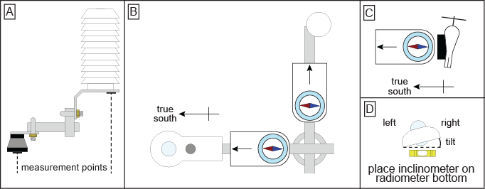

Station name: | SDM |  | Date: | 03-05-2026
STATION HARDWARE
To do? | Done? | Item | Comments
Replaced | yes | Loggerbox | ID arrival: M4 - 06  ID departure: M4-10
New | Yes | Modem IMEI | IMEI arrival: 300534064387800  IMEI departure:300534063818810
Replace | Yes | Radiometer | Serial arrival: 110723  Serial departure: 213255
Replace | Yes | Lufft | Done, cable on the Lufft end is held together by zip-ties.
Replace | Yes | Wind sensor upper | Type arrival: Black / White  Type departure: Black / White
Replace | Yes | Wind sensor lower | Type arrival: Black / White  Type departure: Black / White
Replace | Yes | Vaisala upper
Replace | Yes | Vaisala lower
Replace | Yes | SR50 upper
Replace | Yes | SR50 lower
Extend | Yes | Thermistor string
 |  | Iridium antenna | The cable end for the loggerbox was broken, the pin inside was gone. Replaced with a working cable, so everything works.
 |  | Solar panel
Replace | Yes | Battery box | Burial under lower lufft: YES / NO  Location if NO:
Extend? | No | Mast

NOTES (e.g. sensor damage, must-do at next visit)
- Lufft cable plug broken – change on next visit
- Old Upper Vaisala reused
- GNSS rover mounted 37cm above snow
- New height of snowboard – pole: 148 cm and to bamboo: 242 cm
- Lufft height 405 cm
- No liquid GNSS installed. Antenna cable used for station Iridium antenna cable.

